**Ambavaram Tirumala Kondareddy (192210642)**

**4. Create a visual representation in Figma highlighting the key elements of mobile network protocol stacks.**

**Aim: -**

**Design a visual representation in Figma highlighting the key elements of mobile network protocol stacks.**

**Procedure: -**

**1. open Figma**

**2. Create a new file**

**3. Select the Frames**

**4. Fill in the content that is required for presentation**

**5. Design Visual Elements**

**6. Make it Interactive**

**7. Add Annotations and Explanations**

**8. Incorporate Multimedia**

**9. Storyboard Animation**

**11. Review and edit the Prototype**

**12. Save and Share**

**Design: -**

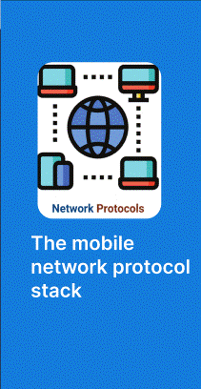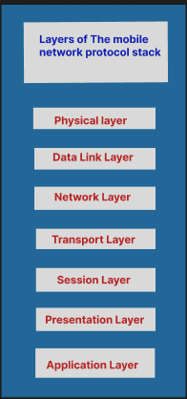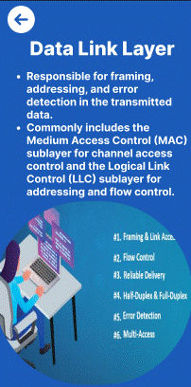

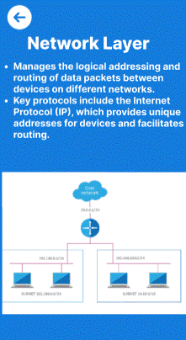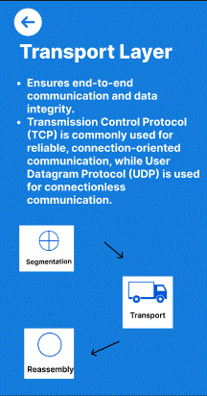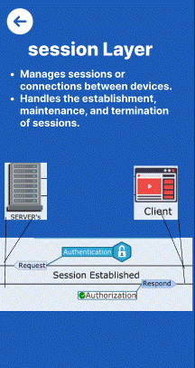

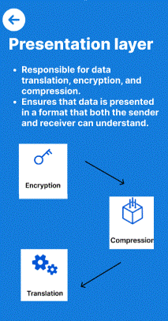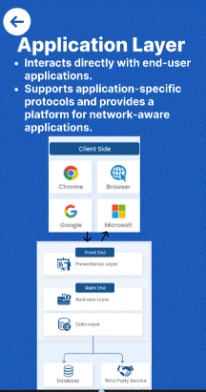

**Prototype: -**

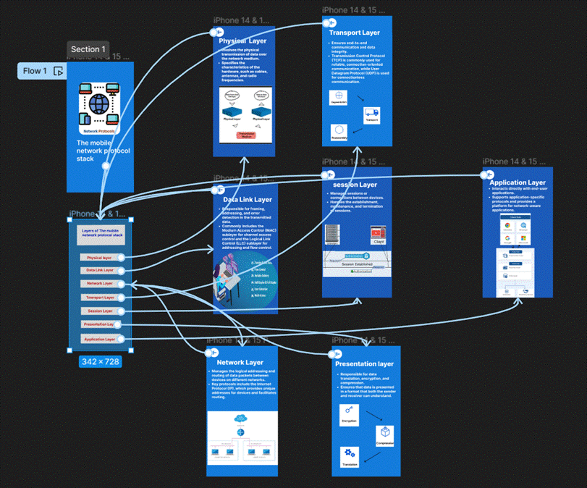

**Result: -**

Hence the visual representation in Figma highlighting the key elements of mobile network protocol stacks is created and executed successfully